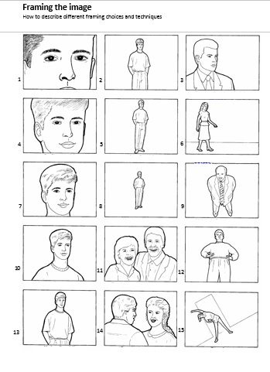
Word Bank

Extreme Close-Up Medium Long Shot
Close-Up Looking Room
Long Shot High Angle Shot
Big Close-Up Walking Room

Very Long Shot Low Angle Shot
Tilted Frame Medium Shot
Over the Shoulder Medium Close-Up
Two Shot

