Digital Media 1
Animation, 104.00-104.02
Overview and Objectives:
- 104.00 Apply animation procedures used to create digital media. (18% total)
- 104.01 Understand concepts used to create digital animation. (10%)
- 104.02 Apply procedures to create digital animation. (8%)

Materials:

- 104.01 Animation Concepts Notes
- 104.02 Animation Procedure Notes
- Blackboard Class Site
- Skeleton Notes Packet
- Class Blackboard Site
- iMac computers
- Internet
- LCD projector
- Microsoft Word
- Elements
- Adobe CS4 Flash
- Shape Tween Tutorial
- Motion Tween Tutorial
- Bouncing Balls Tutorial
- Flying Text Tutorial
- Snowboarder Project video tutorials
- Snowboarder Rubric
- Internet Add Rubric
- City Animation Tutorial
- City Animation Tutorial Rubric

Essential Question:
- What are the basic concepts used to create digital animation?
- What are the basic procedures for producing digital animation?
Estimated Time to Cover:
- 105.01: 10% - 9/90 days
- 105.02: 8% - 7/90 days
  - Note: Estimated time is based upon the fact that 10% of the end-of-course questions will come from this objective. Some objectives may require more or less than the estimated time based on the lessons and activities.

105.01 Expected Outcomes:

- Upon completion of this objective, the student will be able to:
- Understand basic concepts of digital animation
- Definition of digital animation
- Historical developments of animation
- Use of digital animation
- Understand the software features used in digital animation.
- Drawing
- Scaling
- Layering
- Key framing
- Tweening
- Anchor point adjustment
- Transitions
- Understand the different animation categories.
- Frame based/flip book
- Vector/path
- 2D
- 3D
- Understand the different digital animation formats.
- Animated GIF
- SWF
- MOV
- AVI
- Understand the types of equipment used to create digital animation.
- Cameras
- Computers
- Scanners
- Drawing tablets

105.02 Expected Outcomes :

NOTE: Procedures for creating digital products can vary widely, depending on whether the end product is audio, video, graphic, animation or website. The terminology used to describe those procedures in the “real world” also changes depending on the work environment.
For purposes of consistency from objective to objective within this course, this curriculum refers to the same four-phase process for producing a digital media element, regardless of the end product. The four steps are planning, preparation, creation, and distribution. The intent of this approach was to emphasize a logical ‘rhythm’ for getting things done. These materials aim to lay out a logical sequence of events for each element. The concepts of thinking through a project before you create the product are of primary importance.
Upon completion of this objective, the student will be able to:
- Apply procedures to plan for digital animation
- Define target audience
- Brainstorm – write down ideas
- Coordinate equipment needs
- Apply procedures for technical preparation for digital animation
- Computer
- Type of software
  - 2D
  - 3D
- Audio and/or video files as needed
- Audio and/or video equipment as needed
- Scanner
- Drawing tablet
- Motion capture equipment
- Apply procedures to create digital animation
- Design animation
  - Import necessary graphics, audio, and video files into the software program
  - Place or draw objects on independent layers
- Edit animation
  - Scale and manipulate objects
  - Set keyframes
  - Set anchor points
  - Adjust opacity or alpha if desired
  - Adjust position if desired
  - Add transitions
  - Tween or render keyframes
  - Save
- Apply procedures to prepare digital animation for distribution.
- Export (determine the file format needed)
- Determine the distribution type (CD, DVD, or Internet download/streaming)

Teach 1: Animation Concepts
- Bellwork: Students will have a Bellwork assignment each day they must complete in the first 5 minutes of class on a Bellwork worksheet. They must record the date, the question and their answer; these are submitted each Friday for a Quiz/Bellwork grade. Bellwork answers are reviewed each Friday.
- Explain that we will be examining Animation in this unit.
- Direct students to log on to their computers, go online, and log into Blackboard. Once there they need to launch the Animation Concepts Notes.
- Hand out the Notes Packet for students to use while discussing the unit, these will be due on test day and students should use these for note taking and study purposes.
- Begin Notes, explaining each slide in detail with examples. Students will listen to explanations, read online notes, fill in Notes Packet worksheets, answer oral review questions, and participate in class discussion on Animation.
- Students will read and review “How Computer Animation Works” and “A History of Computer Animation” Articles found on the Class website. Students may choose one of the five options listed on class website to summarize and thus reinforce lesson outside of class.
- Homework Options:
  - Write a 2 paragraph summary of what you read (5 complete sentences in each), typed, 12 point font, times new roman, and double spaced.
  - Create a PowerPoint or Prezi describing in bullets the information from the article. Must be a minimum of 5 slides, not including the title slide.
  - Write a quiz about the article. Write the questions and answers. If short answer, 10 questions that have at least a 2 sentence answer OR a multiple choice quiz with 20 or more question. Make sure you write well thought out questions that incorporate all the information from the article. Must be typed, 12 point font, times new roman, and double spaced.
  - Glogster Poster creating a visual explanation describing the information. Must include enough information to summarize the article in order for the viewer to get the main ideas and points. Please print off your poster to turn in.
  - Give an oral report about what they read that is a minimum of 4 minutes summarizing all the key points in the article.

Teach 2: Shape Tween and Motion Tween Tutorials
- Students will complete 2 worksheets labeling the areas in Adobe CS4 Flash to help familiarize them with the locations of everything in the program and to have as reference during classwork and projects.
- Students will launch Flash and follow along with teacher demonstration of tools in Flash.
- Students will watch and follow along in Flash as teacher demonstrates the following:
  - Timeline
  - Stage
  - Motion Path
  - Tools
  - Frames per second (fps)
  - Importing graphics
  - Importing sound
  - Drawing
  - Scaling
  - Layering
  - Key framing
  - Tweening
  - Anchor point adjustment
  - Transitions

Teach 3: Bouncing Balls Animation Tutorial
- Students will log on to Blackboard and following the directions create a bouncing ball animation in Flash. Students will download the tutorial and then launch Flash and follow the step by steps instructions while applying their own creative ideas to the directions to have a unique animation.
- Class Website Directions:
- Bouncing Balls Tutorial
This first project in Flash is meant to give you a little practice making things move around the stage. Create a new project and change the FPS to 12. Change the background color to whatever color you like. Create at least eight balls that will bounce around the stage and off the walls - put each ball on a different layer! Make each ball bounce off the ground, walls, or ceiling at least six times. Make sure your lock each layer after you have finished animated that particular ball.
Save your project as a .FLA file and name it firstname+lastname+ bounce.fla. Export the file as a .SWF and name it the same thing. When you have completed the project, show it to Ms. Scales to demonstrate your ability.
Teach 3: Flying Text Animation Tutorial
- Students will
- Class Website Directions:
- Flying Text Tutorial
Any animation that is meaning to convey a message usually requires the animation of text. In this project, we will learn how to easily animate the letters in your name.
First, create a new Actionscript 3.0 File in Flash. Use the text tool to type out your full first name. Right click your name and break the letters apart, then distribute them to layers. Click the first frame on each letter layer and convert each one to a symbol. Remember to change the type to "Graphic" for this animation. Create new keyframes at 5 frame increments and move all of the letters around on the stage. Move them anywhere you'd like at each keyframe and rotate them around for interest. Once you have reached 30 frames total for each letter, create a classic tween for each movement. You may also take the extra step and add an underline or animate your last name as well.
Inside this project folder, you will find a tutorial with step by step instructions on how to complete this project successfully. Also located in the folder is an example of what a finished product might look like. Once you have finished this project, save it as a .FLA file and name it firstname+lastname+flyingtext. Export the project as a .SWF file.
Teach 3: City Animation
- Students will
- Class Website Directions:
Teach 4: Snowboarder animaiton Project
- Students will create a slip book based animations that focuses on frame based animatin versus tween based animations.
- Students will continue to enhance drawing skills in Flash.
- Students will learn and use new Onion tool in Adobe Flash.
- Students will use scenes to enhance and organize animations more effectively in Adobe Flash.
- Students will watch Online Snowboarder tutorial provided on class website through YouTube and graphics needed to create a 3 scene animation of framed based animations.
- Teacher will demonstrate new tools on LCD projector and the steps to create their first scene.
- Class Website Directions:
- The previous projects we use computer generated formulas to define the movement (called tweens). In this project, we will learn frame-based animation techniques. of Adobe Flash. It can be a little bit more time consuming, but it is easier to create exactly the type of movement your envisioned.
This project will teach you how to utilize the onion skin which is useful to create smooth, consistent movement with the frame-based technique. You will also learn how to create separate scenes within one animation project. Use the provided files and video tutorials to learn how to create this project. If you run into any problems, the instructor will be available as a resource.
When you have completely finished, use the rubric to make sure you are meeting the project requirements. Export your project as a .SWF project and name it lastname + snowboarder (ex: scalesemilysnowboarder.SWF).
Grading Rubric:
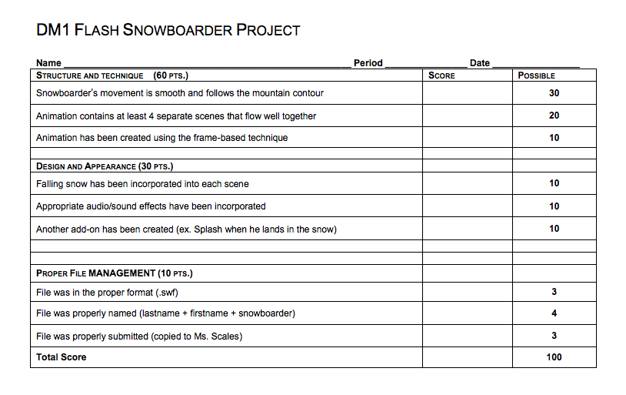

Teach 4: Internet Flash Ad
- Students will use skills learned in earlier projects to create a 15 second animation advertising a movie or TV show that would be shown as a banner on a website.
- Students will not be provided with tutorial or guide to create project, but may use earlier activity/project tutorials to aid in the creation of this project.
- Class Website Directions:
- Flash Internet Ad
The advertising agencies have heard how talented you are in Flash and want you to create the next internet advertisement! Pick your favorite TV show, movie, product, etc. and find pictures and appropriate audio from the internet (there is a website located in this project folder that might help).
The first step in creating a good animation is to plan it out. Using the storyboard form given to you in class, plan out your animation by drawing what type of motion you will create and the sound effects you will use in your Internet Advertisement. Use two blocks for each scene in your ad. As you create your advertisement, you may edit your storyboard to reflect the changes.
After you have planned everything, go into Flash and create a new Actionscript 3.0 and leave the FPS at 24. Begin importing pictures, audio, and other elements to develop a creative, attractive advertisement for your chosen show or product. The final project must also have at least 3 scenes total, easing applied to every tween, and alpha adjustments to the pictures. It must also be at least 15 seconds in length.
Once you have finished your project, use the rubric provided below to make sure you have satisfied all of the project requirements. Save the .FLA file and name it firstname+lastname+ internetadd. Export the .SWF file and save it to your Animation folder on your desktop.
- Grading Rubric:

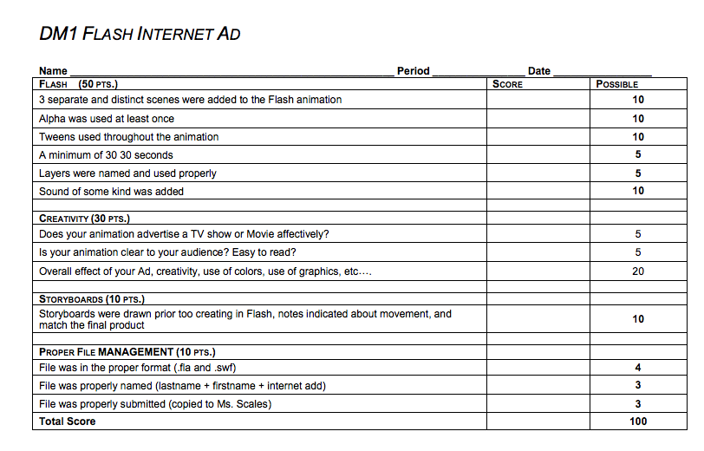

Adaptations/Modifications:
    - Teacher Copy notes will be provided as needed.
    - Modified Assignments for testing, classwork, and homework will be provided as needed.
    - Extended time and separate setting on assignments and tests will be provided as needed.
    - All information, class notes, and assignments are available on class website for all students.
    - Study guides prior to assessments/test will be provided as needed.
    - Extra help an tutoring is available during SMART Lunch each week on Tuesdays and Fridays, and other days if requested by student.
    - All materials are put on Blackboard for easy accessibility by students.
Extension of Lesson Plan:
- As students need or want more practice in Flash, they will be able to access a variety of different activity assignments they may complete that will allow them to critically think, be creative, and produce a product independently.
- Students may challenge themselves to go beyond the tutorials and minimum requirements to enhance their classwork and projects.
Assessment:
- Students will be tested using an Element/teacher made test to evaluate understanding of material covered.
- Students will complete daily Bellwork to demonstrate their understanding of material covered in class.
- Students will complete tutorial classwork assignments to demonstrate their understanding of the use of the Photoshop program
- Students will complete Flash Projects to demonstrate their ability to apply the knowledge gleamed in the completion of the tutorials to a unique and creatively driven assignment without having the steps provided to them.
- Students will complete homework summaries to demonstrate understanding of material outside of class.

