Responsive Website Wireframe Pre-Production Planning

Company Name: type here
Student Name: type here

Index Page
3 Carousel Images (describe images & captions for each):
- Image 1 (describe): Type here
Heading: Type here
Caption: Type here
- Image 2 (describe): Type here
Heading: Type here
Caption: Type here
- Image 3 (describe): Type here
Heading: Type here
Caption: Type here
Heading: Type here
Paragraph (1 sentence): Type here
Thumbnail Image (describe image): Type here  Heading: Type here  Paragraph (4-5 sentences): Type here | Thumbnail Image (describe image): Type here  Heading: Type here  Paragraph (4-5 sentences): Type here | Thumbnail Image (describe image): Type here  Heading: Type here  Paragraph (4-5 sentences): Type here
Footer: © Copyright (year). All rights Reserved. (Company address)

About Us
3 Carousel Images
COPY & PASTE FROM INDEX PAGE ABOVE
Heading: About Us
Paragraph (about 4 sentences): Type here
Heading: History of (company)
Paragraph (about 10 sentences): Type here
Footer: COPY & PASTE FROM INDEX PAGE ABOVE

News
1 Main News Images (describe):
Type here
Heading: Latest News: Type here
Paragraph (about 10 sentences): Type here
Footer: COPY & PASTE FROM INDEX PAGE ABOVE

Gallery
3 Carousel Images (describe images & captions for each):
COPY & PASTE FROM INDEX PAGE ABOVE
Thumbnail Image (describe image): Type here | Thumbnail Image (describe image): Type here | Thumbnail Image (describe image): Type here
Thumbnail Image (describe image): Type here | Thumbnail Image (describe image): Type here | Thumbnail Image (describe image): Type here
Thumbnail Image (describe image): Type here | Thumbnail Image (describe image): Type here | Thumbnail Image (describe image): Type here
Footer: COPY & PASTE FROM INDEX PAGE ABOVE

Examples from Tutorial
Index Page

About Us Page
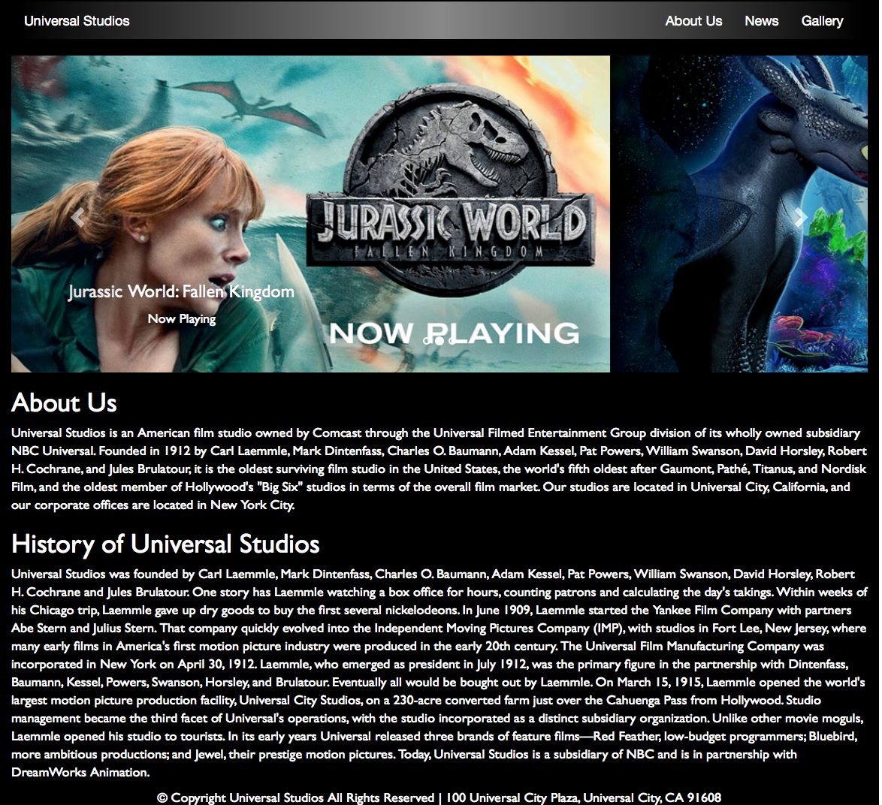

News Page
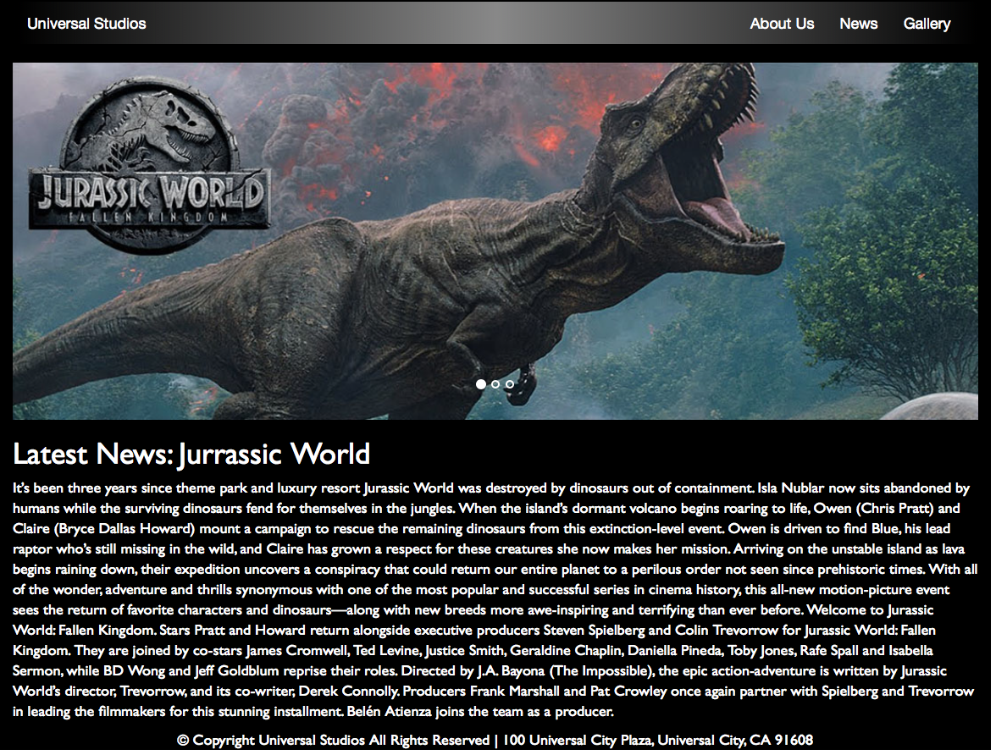
Gallery Page

