2.02 Create a Living Room Illustration

Objective: The student will successfully demonstrate the ability to create an illustrated living room design, which includes furniture and accessories in a vector software program.

Key Concepts Utilized: The students will demonstrate the ability to use lines and shapes, the direct selection tool, stoke style and color, fills, gradients or textures, stacking order, the pathfinder, and warp effects. The students will also utilize the Principles of Design when creating this project.

Use your Adobe Illustrator to design a living room in which each item in the room is created by using available tools.

Some ideas for items for your room could be:

Sofa
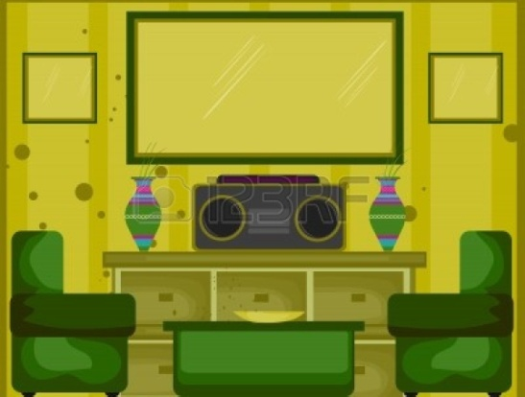
Chair
Lamps or Ceiling Lights
Coffee Table
Flat Screen TV
Windows
Curtains or blinds
Vases
Flowers or plants
Book shelves with books
Mirror
Artwork on walls
http://www.123rf.com/photo_4090191_living-room-illustration-10-of-10.html
Clock
Candles
Or anything else you want.

You are required to make at least eight different items, but you can put as many more as you want. Check out 123RF for some inspiration.

When you are finished with your project, save the illustration as LastNameFirstNamePeriod#LivingRoom.ai. Once you have saved the illustration Export the file as a PNG called LastNameFirstNamePeriod#LivingRoom.png.

